

BACKGROUND

Cancer Research UK is the world’s leading cancer charity dedicated to saving lives through research, funding half of all UK cancer research. Our groundbreaking work into the prevention, diagnosis and treatment of cancer has seen survival rates double in the last 40 years. Our scientists and doctors have contributed to most of the world’s top cancer drugs and we have pioneered the use of radiotherapy to treat cancer.

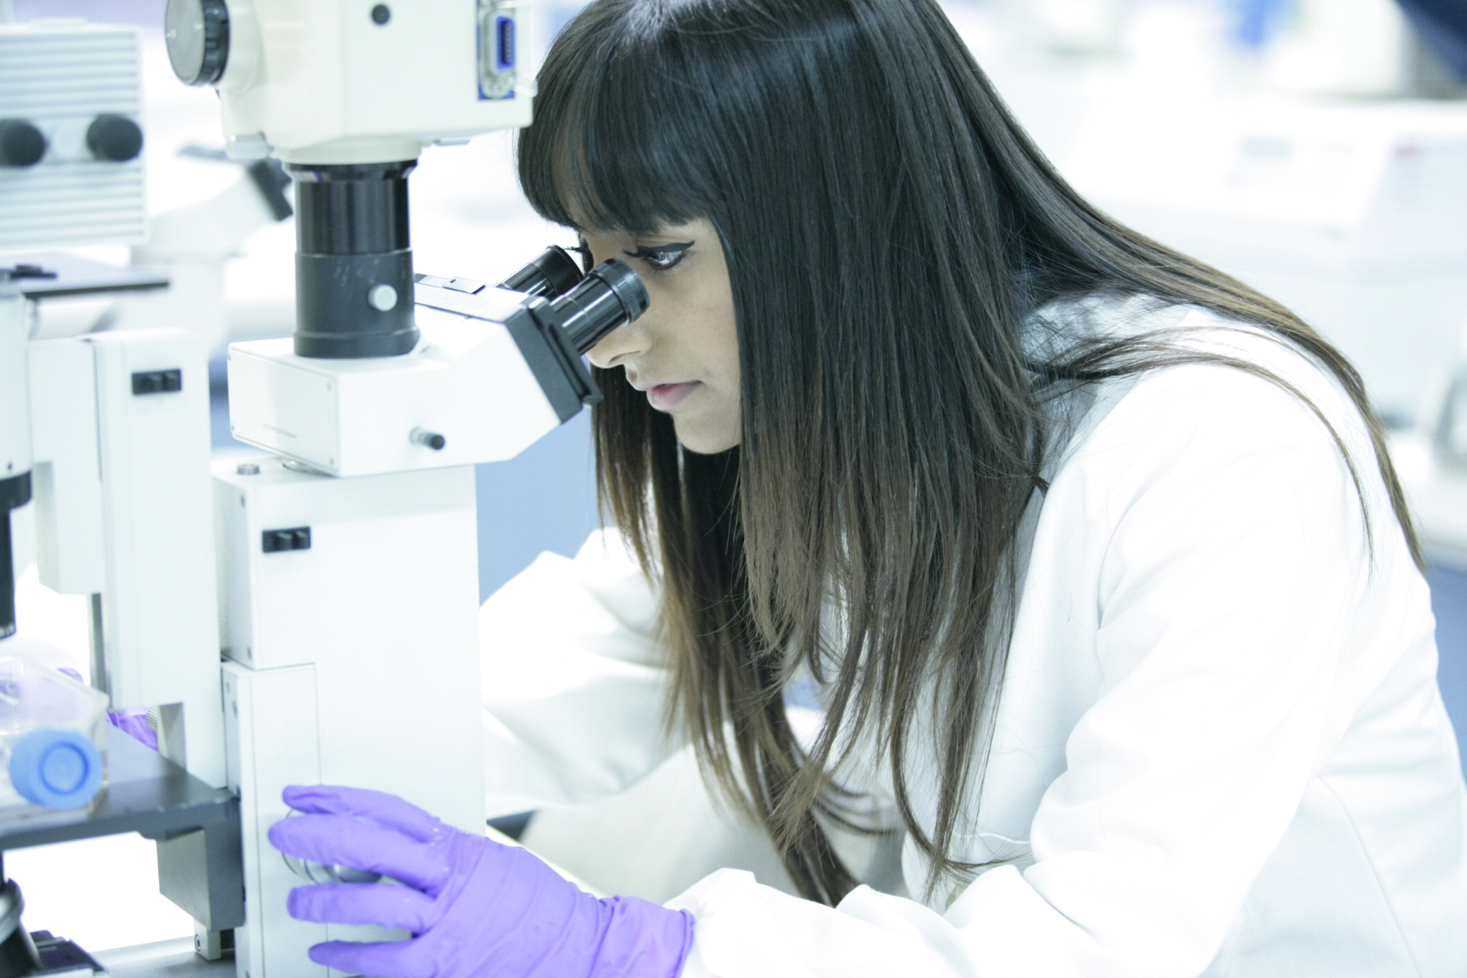
Great researchers are at the heart of groundbreaking cancer research.
We work with the best scientists and partner organisations across the globe to deliver our vision.

We’re in the Golden Era of research.

Cutting-edge techniques are driving rapid progress in new ways to detect, monitor, diagnose and treat cancer.

We’re hurtling into an era of personalised medicine; treating a patient not by their cancer type, but by their cancer’s genetic make-up. Tests that reveal the genetic make-up of a patient’s cancer can help doctors to tailor the treatment accordingly. That means patients will get the RIGHT treatment, first time, with fewer intolerable side effects which could have a major impact on survival rates

To develop these tests – and the personalised medicine – we need to decode genetic information. And stunning advances in technology mean we can do this faster than ever. But it still requires analysis of huge amounts of genetic data by real people that cannot be left to computers alone. And that’s why it takes so much time.

This job needs human intuition and the human eye. It is analysis that researchers are doing every day; looking for patterns, exceptions and abnormalities.
But with the collective power of hundreds of thousands of people, and their eyes, we could speed up this research by years, and save lives.

We believe that clues to curing cancers are buried within our data.

This year alone we are running over 200 trials producing terabytes of data for each one.
A typical trial can take up to 4 years to complete and we need to find a way to reduce these time frames.

With the collective power of hundreds of thousands of people, we could speed up this research by years, and bring forward the cures for thousands of cancer patients. It could be the solution to our data problem.

This is all about authentic science i.e. crowd sourcing huge numbers of people to complete a genuine scientific task.

CRUK will host a GameJam at Google's campus building bringing together the charity’s world-leading scientists alongside technology gurus – supported by *Amazon, FaceBook and Google –with a diverse mix of developers, coders, gamers, scientists and programmers.
Challenge: We need to create a novel, engaging and scientifically robust way for the wider public to usefully contribute in helping us to accelerate cures for cancers. And enjoy doing it.

We believe a GameJam will help us to find the right solution and the full challenge will be revealed on Friday 1st March

We have already had success in this field, having launched Cell Slider in October 2012. The Citizen scientists using Cell Slider are analysing breast cancer tumours by playing a game of matching pairs. We are testing the hypothesis that citizen scientist pathology scoring is as accurate as scoring made by pathologists. Within the first 3 months the public have successfully completed a dataset that would typically take 18 months. This is real.

Please contact: amy.carton@cancer.org.uk to find out how you can get involved and register.

GAMEJAM AGENDA

FRIDAY: (NB Press welcome during the Friday session)
6.00PM: WELCOME DRINKS & SIGN IN & ICEBREAKER
7.00PM: WELCOME AND PRESENTATIONS
7.00PM CRUK Welcome
7.15PM CRUK Overview
7.30PM CRUK Scientist Gene Data Overview
7.50PM Dr. Chris Lintott Citizen Science Alliance
8.20PM Amazon Introduction
8.40PM Facebook Introduction
9.00PM Introducing the Hackers challenge

9.30PM: TEAM FORMING AND SOCIAL DRINKS

SATURDAY:
9.30AM: COFFEE AND PASTRIES
10.00AM: SETTING THE SCENE
11.00AM: DESIGNING AND DOING
12.00PM: Facebook/City University Workshop 1 hour
7.00PM: SOCIAL DRINKS & WORK TILL LATE

SUNDAY:
9.30AM: COFFEE AND PASTRIES
10.00AM: SETTING THE SCENE
11.00AM: DOING AND TESTING
5.00PM: TEAM PRESENTATIONS & JUDGING
7.00PM: CLOSING AND THANK YOUS AND AWARDS
8.00PM: SOCIAL DRINKS

